

Name: Saravanan Subramaniam

Login ID: saravanan@oasis-portal.com

Course title: Essentials of Marketing and Customer Relationship

Subject Code: BHM 02

Submitted date: 17TH July 2017

**Table of Contents**

|  |  |  |
| --- | --- | --- |
| **No** | **Details** | **Page** |
| 1 | Executive Summary | 2 |
| 2 | Introduction | 3 -4 |
| 3 | Assignment Question |  |
|  | Part 1 | 6 - 8 |
|  | Part 2 | 9 - 12 |
|  | Part 3 | 13- 16 |
|  | Part 4 | 17 - 19 |
| 4 | Conclusion | 20 |
| 5 | References | 21 - 24 |
|  | Appendix | 25 - 27 |

**Executive Summary**

The propose of this assignment is what I learned about marketing and customer relationship. Firstly I will explain about the marketing in hospitality and importance of marketing. Then I will brief the differences between marketing versus customer service. Furthermore I will covered about the character of marketing and customer service. Thirdly I will talk about marketing strategies and how its apply in hospitality management. Finally I will explain in details on customer service skills and characteristic and in addition I will talk about the importance of hospitality customer service.

**Introduction**

The history of marketing as we know it began of simple trying to sell goods or service. To develop communication for selling goods or services has been around the times of ancient. It may not been recognized as a marketing. Starting in the 1960 the marketing revolution published by Robert Keith was a work study of the history of marketing. There is four element called the 4P of marketing:

1. Product
2. Price
3. Place
4. Promotional strategy

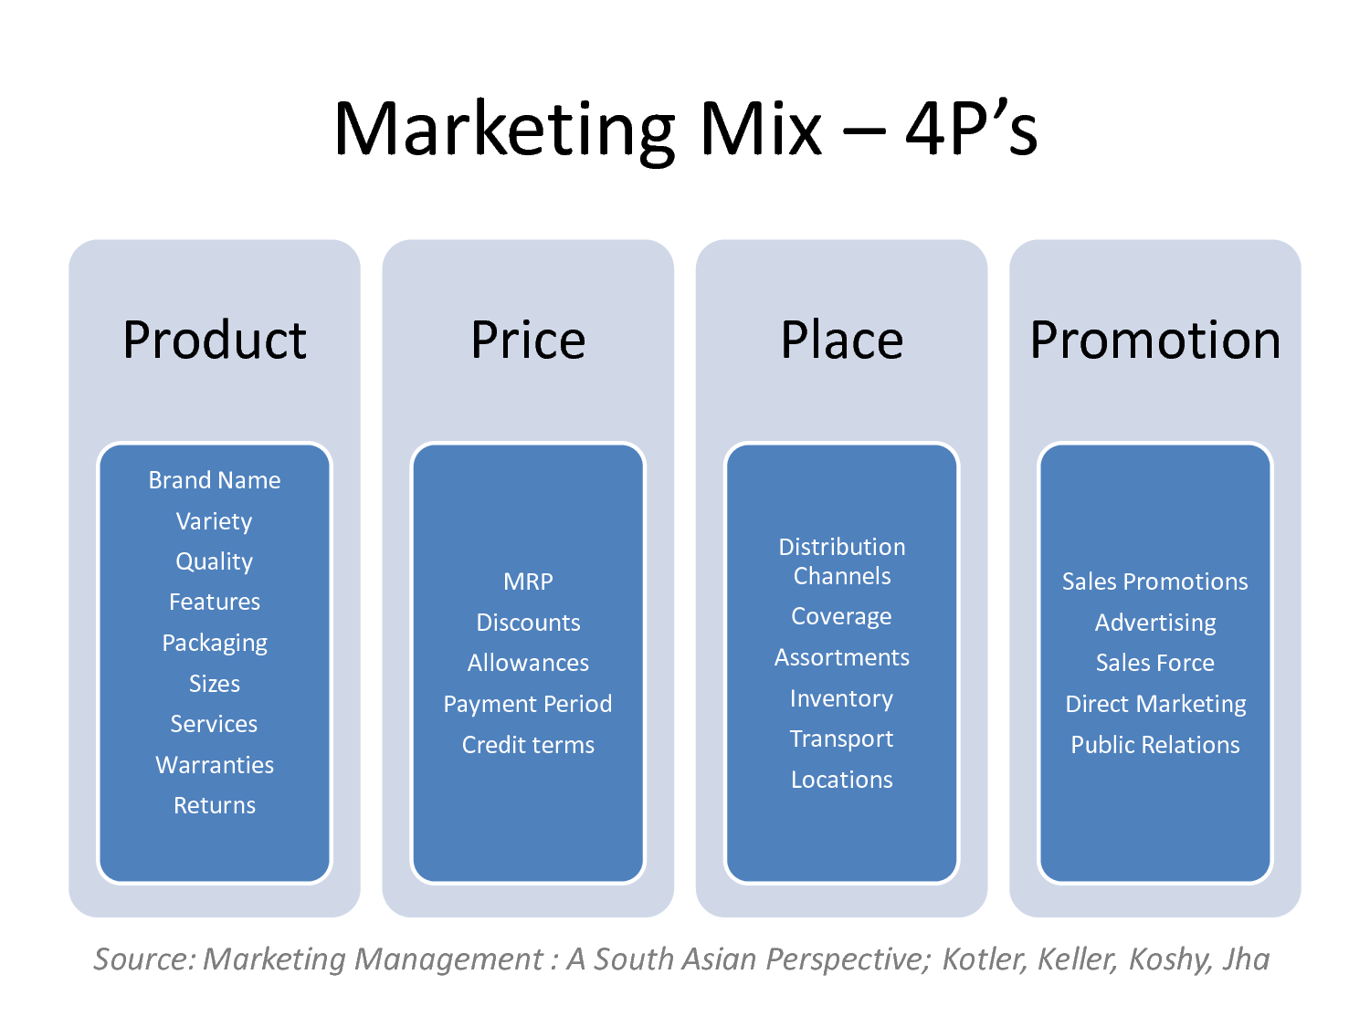

Marketing is satisfy customer, keep the customer and create customer, has little to do with the service provider and everything to do with the customer. Great marketing understand what buyer wants or gives it to them and delighting the buyer and consumer to achieve profit or their goal.

Why do we need to study customer relationship? Customer relationship is a term that firm use to manage and analyze customer interactive and data, with a goal of improving business relationship with purchaser, assisting in the customer retention and sales growth. Customer relationship helps in profiling prospects, understanding their need and building relationship with buyer. Moreover, it integrates back and front office system to create database of customer.

**Assignment Questions**

**Question 1**

Briefly explain about Marketing in Hospitality and The importance of Hospitality Marketing.

**Answer**

What is marketing? Marketing is begin with simple sell goods or services. It includes targeting, communication (advertising) and public relations. Designs to matches the right messages to find someone who has a personal connection with the product or services. In business tem of customer needs and customer satisfaction. In other way it develop a demand for the product and fulfilling the buyer needs. Hospitality marketing getting firm product or services out to consumer and its takes segment of hospitality industry such as hotel, bar, restaurant, resort and more to promote.

**Marketer**: identify the good or services depends by consumer and also behalf of the company. Promote and exchange for money.

**Markete**d: organization use internally the marketed products or services to describe.

**Target market**: identify the customer and the tailor marketing pitch. The buyer who needs and desire most closely match with the products or services.

**Marketing Concept**

To which organization goal or target can be achieved by identify and satisfying customer needs, increase sales, maximize profits and beat the competition. There are five concept of marketing:

1. Production
2. Product
3. Selling
4. Marketing
5. Societal marketing

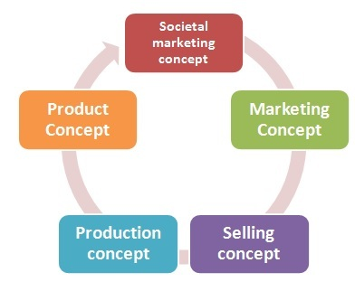

**Importance of marketing**

Why is it important? It can increase sales, grow business and engage customer. A good marketing strategy create the possible to achieve their target and goal. Without marketing there is no way for people to become familiar with the career.

By the way these are five importance of marketing:

1. **Getting word out**

Which is supply the products or service provides must be known to be potential purchaser. In order to get large number of customer, needs to promote the products or services via online strategies. Nowadays a lot of them using social media network it will very helpful and successful to promote a brand. Also proven to be excellent platforms. In addition the first step towards achieve thee good for their business and able to reach their target audience via social media network.

1. **Company reputation**

It takes a lot of time to build a company reputation in today market, but once build it take strategy to maintain. As the firm reputation grows so does the sales will increase and generate revenue. Higher sales will lead to more customer and further expansion. Then a lot of customer will talking about the product or services. Since the buyer will tell to their peers and family about the product or services.

1. **Healthy competition**

People will think that it would be better if there is no competition. The lack of knowledge to utilize competition growth of the organization. An important aspects for the economic growth. It not only benefits for consumer, but also in business in different ways. There are five reason why competition is good innovation, customer service, complacency, understand the core market and education.

1. **Higher sales**

Certainly one of the main goal or target to get higher sales. Is to get customer talk about product or services. Moreover must need to know what customer wants, is the only way to satisfy their needs. The main goal is to make a higher profit to develop a good marketing strategy that will reach to more customer and generates the sales. They always stay ahead of the competition.

**Question 2**

Explain the differences between Marketing vs. Customer Service. Explain the ethics of the Marketing and Customer Service.

**Answer**

What are the main differences between marketing and customer service? Marketing is a sales and customer service is a tools carry out the concept. Marketing identify the sales, public relation, goals or target by an organization and advertising. Customer service may called data about the buyer and create target customer profiles. In addition also effectively finding opportunities to create special promoting to the long-time customer and build a relationship.

|  |  |  |
| --- | --- | --- |
| **Marketing** | **Aspects** | **Customer services** |
| Generating leads and make sales. | **Advantage the ears on the ground** | Troubleshoot or resolving issues. |
| Make sure understand the real features or benefits of the products or services. | **Patient** | Spend less time think about purchasing. Give the customer knowledge and satisfaction is important what they should have or wants. |
| Building relationship than marketing products or services. Moreover branding and name recognition. | **Relationship** | Build the trust and reliability with customer. Gain relationship that continually make profits for years to come. |
| Should realize that it is time well invested. Important part of marketing a services because time frame able to deliver while still managing and providing services to others. | **Time** | Fully informing customer about the products or services, it will help to reduce the complaints. Additionally happy and smart customer are the better way to improve company reputation and sales. |

**Ethics of marketing**

Determining good or bad and right or wrong moral behavior. And marketing action may be judged. Ethics is a subject because everyone has subjective judgment about what is right or what is wrong.

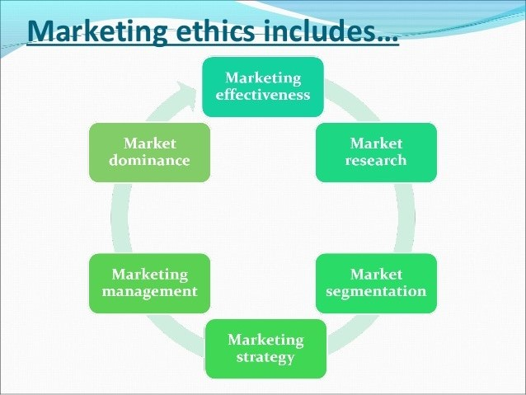

1. **Marketing effectiveness**

Is simply the number of leads generated by tactical activity and mire generally as the return on marketing investment against set of objectives?

1. **Marketing research**

Very important to understand at the outlet, modern concept of marketing revolve around the customer. Satisfaction of customer is the main key of marketing.

1. **Marketing segmentation**

The process of dividing a market of potential customer into group or segments. It created consumer who will respond similar of marketing and share traits.

1. **Marketing strategy**

Today social media is more than just a channel or tactics and it is an imperative that should be present in every marketing strategy can unlock peer to peer communication and recommendation that are built in social media network.

1. **Marketing management**

Defined as the process of overseeing and planning new products development, advertising, promotion and sales.

1. **Marketing dominance**

Is a measure of the quality of a product or services relative to competition?

**Ethics of customer services**

Customer services play a vital role in customer service management, cause they often the point of contact between business and client. Customer service ethics influence the manner which representative behave are the most important aspects. Essential building trust with customer and create guest experience.

1. **Reliability**

Customer expects products or services provide to be dependable and accurate when having communication. More important need to be caution about how some of our communication translate to customer.

1. **Competence**

This measure knowledge and skills level of the products or services. Without knowing about the products from front and back, that won’t know to help customer when they having problem.

1. **Time management skills**

Spend more time with customer and need to be concerned with getting customer what they want and their needs.

**Question 3**

Describe about Marketing strategies and how you can apply your studies in Hospitality Management.

**Answer**

What is marketing strategy? Is a process or model to allow a firm to focus limited resources on the best opportunities to increase sales and achieve goals? The marketing strategy of an organization contain the firm value, marketing messages, target customer and marketing plan.

What is SWOT? SWOT is a method was originally developed for business and industry. SWOT stands for strength, weakness, opportunities and threat, it can help the company face the greatest challenge and find most promising new challenge. It provides a tool to explore both internal and external factor.

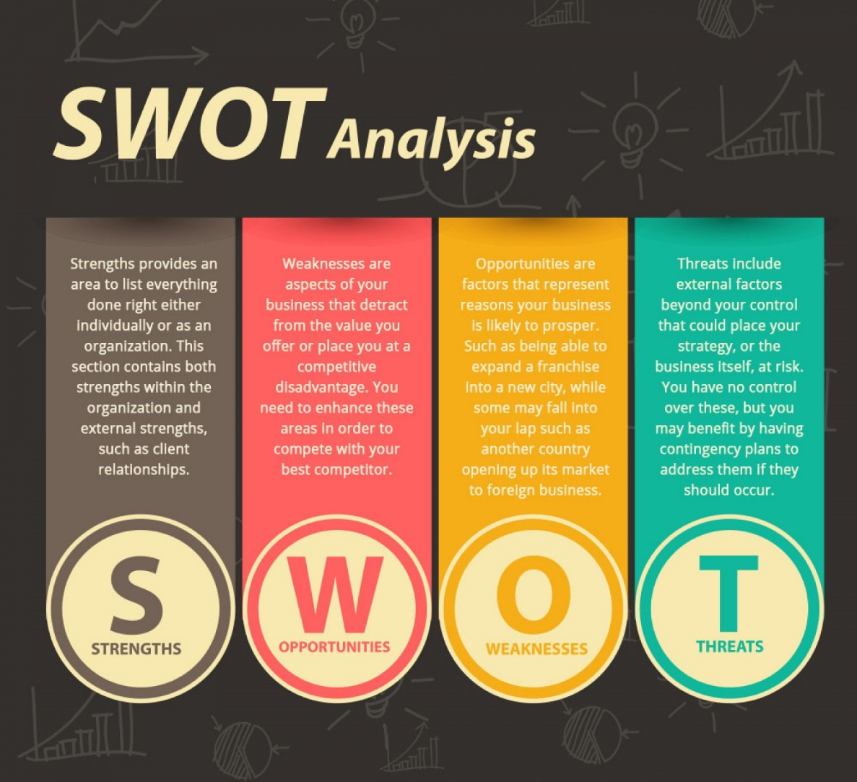

* **Strength**

Could be quality processes and procedure. Describe what an organization excels and separate from the competition. Any other aspects of the business that adds value to products or services. All the respondents thought the location of the hotel and the size of hotel is also categorized as a strength.

* **Weakness**

Stop an organization from performing at its optimum levels. Where the business needs to improve to remain competitive. In addition it can damaged company reputation. Tools such as action plan and goal provide way to improve weakness.

* **Opportunities**

External factor that an organization can use to give it a competitive advantage. A developing market such as social media network and moving into new market segments that improve profits.

* **Threats**

Refers to factors that have the potential to harm an organization. Could be price war with competitor has new products or services. Moreover taxation is introduced on the products or services.

1. **Product**

Can be tangible or an intangible services that fulfills need and want of consumer. Understand the life cycle of a product marketer should be successful and have plan to deal with products or services at every stage. In addition must be designing for special needs.

1. **Price**

Is the cost customer pay for a products or services and must link the price for the real and perceived value of products or services. Will impact profit margin, supply and demand. Therefore make some pricing decision which will help to attract the buyer to get the products or services.

1. **Place**

Put the right product, at the right place and at the right time. The products is sold and how it’s delivered to the market. Moreover how fat its reach to the buyer and the firm have their own target to achieve their goal.

1. **Promotion**

Promotion includes advertising, public relation, social media networking, search engine marketing and more. Must be supported by a well position brand to truly maximize return on investment. A products or services show the buyer why they need it and why they should willing to pay. In addition marketer tend to tie placement and promotion element together so it can attract the customer.

1. **People**

The first impression attempts to influence the attitudes of guest towards the services facilities offered by hotel industry. Advantage by recruiting the right people, training the staff to develop their skills and retaining good staff. People in the target market that is in demand for certain type of products or services.

1. **Physical evidence**

There should be physical evidence that the products or services was delivered. However to create a better customer experience with tangible elements are also delivered with services. Can also refer to the staff how they dress and act.

1. **Process**

Process refer to processes involved in delivering the products or services to the customer. It will save time and money by increasing efficiency. And repeatedly deliver the same standard services to customer. Within the processes there should be defined areas where a customer preference can be accommodated to provide a unique experience.

**Question 4**

Explain in detail on Customer Services Skills and Characteristics. Explain the important of Hospitality Customer Services.

**Answer**

Customer service skill means to be professional, can communicate, efficiency, positive attitude, listening, patience, good body language, knowledge, handle surprise as well, work under pressure and more.

1. **Communication**

If we are not a good communicator, we not probably not go for in customer services. To communicate Cleary and effectively verbal and written. Need proper speaking skills, good grammar and choose the right mode of speaking. Using professional vocabulary and must be conversational and also be approachable at all time. It is verbal communication that is most often used in today’s call center. Never end a conversation without knowing the customer is satisfied or not.

1. **Problem solving**

This should be resolved as soon as possible. Moreover must acquire knowledge about the firm products or services.

1. **Patience**

Some customer will be irritant and some other will be full of questions. Should give a chance to explain the situation and never react negatively. It makes the customer unhappy. And always be patient with customer is as easy as learning to separate the feeling from the situation and understand customer problem. Furthermore try to solve the problem calmly and patiently.

1. **Time management skills**

It includes with smart planning, setting goal, handling, delegation and taking responsibilities. Customer over to someone who can help them without wasting both of their time,

1. **Knowledge**

Simply possessing the knowledge to discuss products or services. In addition need to have training to better understand what firm offer and regular update on events. To deliver services with full of confidence and able to make recommendation to customer about products or services.

Why customer service in hospitality is important? Customer are the heart of hospitality industry. The quality of services and reliability must be on money. It’s the first point of contact between the hotel guest and the hotel. An opportunity gets to impress and create a lasting great impression. That has job to sustain customer happiness and satisfaction. Then where customer are paying attention to the type of services has been receive within the hospitality industry. Where guests are looking to the staff to help them make their staying relax and comfortable. For hotel staff to produce the kind of guest and customer ethics that will impress the customer.

1. **Customer expectation**

Satisfying customer are looking for a memorable experience and energetic services. For guests to leaves a review of their experience on a number of feedback sites. Whatever their experience good or bad. Bad feedback can extremely damaging.

1. **Deliver on promise**

An organization must keep customer happy, but hospitality industry it’s very important to have the guest engaged in order for report business.

1. **Customer royalty**

Always remember happy customer are loyal, which lead to extra mile if need, provide additional items and always tend to impress. Customer are most important asset of the business without them what would we have.

**Conclusion**

In this part, finally I learned and covered about marketing and customer relationship. How it’s applied in hospitality management. The history of marketing as we know it began of simple trying to sell goods or service. To develop communication for selling goods or services has been around the times. Marketing is satisfy customer, keep the customer and create customer, has little to do with the service provider and everything to do with the customer. Customer relationship is a term that firm use to manage and analyze customer interactive and data, with a goal of improving business relationship with purchaser, assisting in the customer retention and sales growth. It can increase sales, grow business and engage customer. A good marketing strategy create the possible to achieve their target and goal. Marketing is a sales and customer service is a tools carry out the concept. SWOT is a method was originally developed for business and industry. SWOT stands for strength, weakness, opportunities and threat. And the seven P’s of the marketing are product, place, promotion, people, process, price and physical evidence. How the functioning in hospitality industry. Customer service skill means to be professional, can communicate, efficiency, positive attitude, listening, patience, good body language, knowledge, handle surprise as well, work under pressure and so on. Customer are the heart of hospitality industry. The quality of services and reliability must be on money. It’s the first point of contact between the hotel guest and the hotel. An opportunity gets to impress and create a lasting great impression.

**References**

1. Business dictionary (2017) Marketing

* <http://www.businessdictionary.com/definition/marketing.html>

1. Laura Lake ( June 09 2017) What is marketing

* <https://www.thebalance.com/what-is-marketing-2296057>

1. Wikipedia

* <https://en.m.wikipedia.org/wiki/Marketing>

1. James Helton what is marketing strategy.

* <http://www.tronviggroup.com/marketing-strategy/>

1. Tech target customer relationship management

* <http://searchcrm.techtarget.com/definition/CRM>

1. Contributing writer what is customer relation.

* <http://smallbusiness.chron.com/customer-relations-43230.html>

1. Wikipedia

* <https://en.m.wikipedia.org/wiki/History_of_marketing>

1. Smriti Chand Importance of marketing.

* <http://www.yourarticlelibrary.com/marketing/7-major-importance-of-marketing-marketing-management/25857/>

1. Sharen (Feb 8 2014) marketing definition and importance.

* <https://www.slideshare.net/mobile/sharen1967/marketing-definition-importance>

1. Ivan Dimitrijevic important of marketing.

* <http://www.feedster.com/blog/the-importance-of-marketing-for-business-success/>

1. [Hitesh Bhasin](http://www.marketing91.com/author/admin/) (April 1 2017) concept of marketing

* <https://www.google.com.sg/amp/www.marketing91.com/concepts-of-marketing/amp/>

1. Business dictionary consideration

* <http://www.businessdictionary.com/definition/consideration.html>

1. Marketing schools ethical marketing.

* <http://www.marketing-schools.org/types-of-marketing/ethical-marketing.html>

1. Supriya Singh (march 3 2014)

* <https://www.slideshare.net/mobile/SUPRIYASINGH12/ethics-in-marketing>

1. Clawtin (Nov 28 2010) marketing ethics.

* <https://www.slideshare.net/mobile/clawtin09/marketing-ethics>

1. Mohit Mahajan ( Jan 17 2016) ethics in marketing

* <https://www.slideshare.net/mobile/mohitmahajan0771/ethics-in-marketing-57147769>

1. Investopedia marketing mix

* <http://www.investopedia.com/terms/f/four-ps.asp>

1. Virginia tan ( Apr 16 2016) customer services ethics

* <https://www.slideshare.net/mobile/VirginiaTran3/customer-service-using-5-ethical-approaches>

1. Kristie Lorette customer services charateristics

* <http://smallbusiness.chron.com/customer-service-characteristics-756.html>

1. [Alison Doyle](https://www.thebalance.com/alison-doyle-2058389) (July 07 2017) customer services skills

* <https://www.thebalance.com/top-soft-skills-for-customer-service-jobs-2063746>

1. Surveymonkey improving customer services skills

* <https://www.surveymonkey.com/mp/6-keys-improving-teams-customer-service-skills/>

1. Ian miller customer services skills

* <http://www.customerservicemanager.com/customer-service-skills/>

1. Golriz Golkar ( 8 April 2016) ten customer services skills

* <http://www.vocalcom.com/en/blog/customer-service/10-customer-service-skills-every-call-center-agent-should-have/>

1. Rick Suttle customer services skill definition

* <http://smallbusiness.chron.com/customer-service-skills-definition-2067.html>

1. Errol Allen ( July 31 2014) customer service characteristics

* <https://www.linkedin.com/pulse/20140731165857-105971089-six-characteristics-of-great-customer-service>

1. [OSCAR KIMANUKA](http://www.newtimes.co.rw/section/author/344/Oscar%20Kimanuka) (december 12 2014) why customer services in hospitality is everything

* <http://www.newtimes.co.rw/section/read/183956/>

1. Hausman and associates ( feb 22 2011) marketing strategy

* <https://www.slideshare.net/mobile/angelahausman/definition-of-marketing-strategy>

1. Business dictionary marketing strategy

* <http://www.businessdictionary.com/definition/marketing-strategy.html>

1. Investopedia marketing strategy

* <http://www.investopedia.com/terms/m/marketing-strategy.asp>

1. Concordia St. Paul importance of marketing in hospitality industry

* <http://online.csp.edu/blog/business/the-importance-of-marketing-in-the-hospitality-industry>

1. Franki Colbert definition of swot analysis

* <http://smallbusiness.chron.com/definition-swot-analysis-43274.html>

1. Tech target swot analysis

* <http://searchcio.techtarget.com/definition/SWOT-analysis-strengths-weaknesses-opportunities-and-threats-analysis>

1. Nicole fallen (march 28 2017) swot analysis

* <http://www.businessnewsdaily.com/4245-swot-analysis.html>

1. Wikipedia

* <https://en.m.wikipedia.org/wiki/SWOT_analysis>

1. Annamarie hanlon (18 April 2017) marketing mix

* <http://www.smartinsights.com/marketing-planning/marketing-models/how-to-use-the-7ps-marketing-mix/>

1. Marketing mix

* [http://marketingmix.co.uk](http://marketingmix.co.uk/)

1. Vikas Singh (December 1 2014) 7p of hotel industry

* <https://prezi.com/m/ub_-_yr8ffxq/7ps-of-hotel-industry/>

1. Jithindas (Dec 23 2012) 7p marketing

* <https://www.slideshare.net/mobile/jithindas05/7-ps-15741761>

1. Hitesh222 7p’s of hotel industry

* <http://m.authorstream.com/presentation/aSGuest125661-1322891-7-p-s-of-hotel-industary/>

1. Sarita Harbourthe difference between marketing vs. customer relationship management

* <http://smallbusiness.chron.com/difference-between-relationship-marketing-crm-57555.html>

1. Kathy Burns-Millyard deferent between marketing products and services

* <http://smallbusiness.chron.com/difference-between-marketing-products-services-650.html>

1. Business dictionary marketing management

* <http://www.businessdictionary.com/definition/marketing-management.html>

1. Wikipedia

* <https://en.m.wikipedia.org/wiki/Dominance_(economics)>

1. Wikipedia

* <https://en.m.wikipedia.org/wiki/Marketing_effectiveness>

1. Business dictionary marketing

* <http://www.businessdictionary.com/definition/marketing-research.html>

1. Business dictionary segmentation

* <http://www.businessdictionary.com/definition/market-segmentation.html>

**Appendix**



Figure 1. 4p of marketing adapted from https://vivekvrs.wordpress.com/2013/10/03/definition-and-description-of-4ps-of-marketing/.



Figure 2. Marketing Concept adapted from [Hitesh Bhasin](http://www.marketing91.com/author/admin/) April 1, 2017.



Figure 3. Marketing ethics adapted from Clawtin (2010 slide 3)

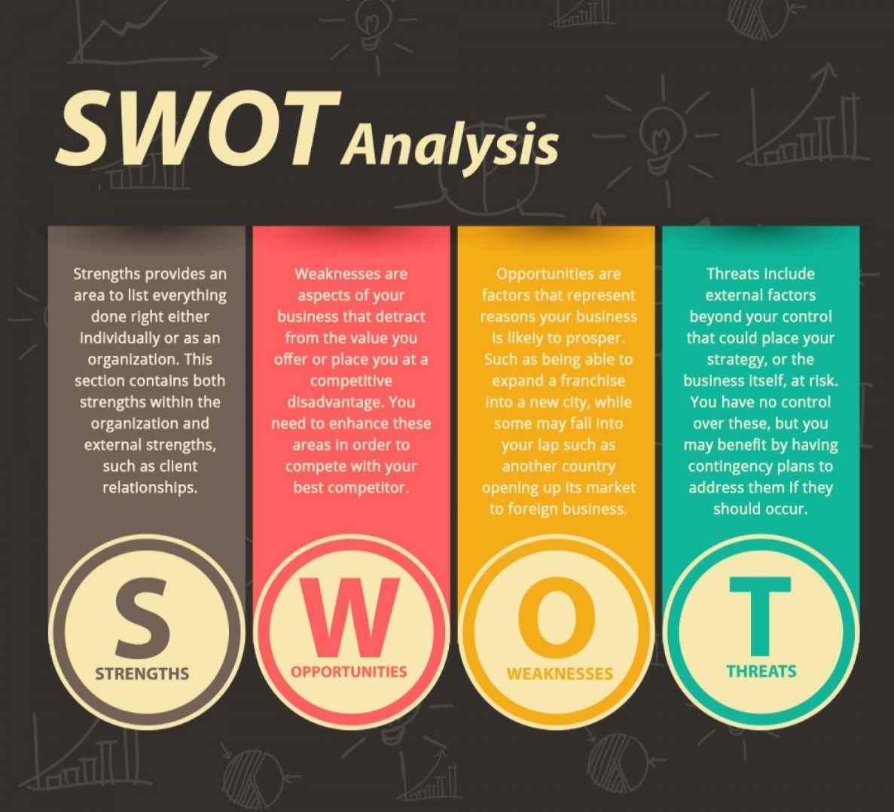

Figure 4. https://www.pinterest.com/pin/392516923755360320/

THE END